Statistics for engineers. Exercise sheet 1: Solutions

1. (i) (ii)

(iii) 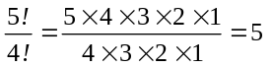 (iv)

(v) 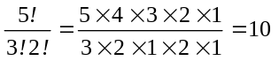 (vi) 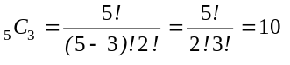

(vii) 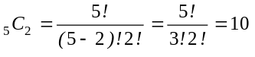
(viii) 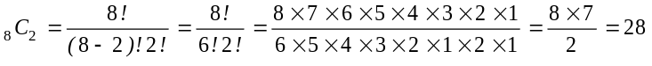
(ix) 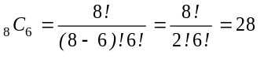
(x)

2. (i) This is the number of ways of arranging 10 distinguishable items.

No. of ways = n₁ x n₂ x n₃ x.... x n₈ x n₉ x n₁₀
(ii) No. of ways = n₁ x n₂ x n₃ x.... x n₈ x n₉ x n₁₀
= 1 x 1 x 8 x 7 x 6 x .....x 3 x 2 x 1 = 8! = 40320

3. Call the event that a paint defect occurs P, the event that a weigh defect occurs W and the event that a finishing defect occurs F. Draw a Venn diagram with intersections for all three events. Start by putting the number of items with three defects in the intersection for P and W and F then use simple arithmetic to put all of the other quantities in their appropriate spaces as shown in the diagram.
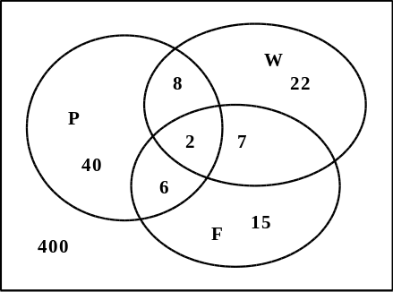
(i) There are 400 perfect items.
(ii) There are 40+22+15=77 items with 1 defect.
(iii) There are 8+6+7=21 items with 2 defects.
(iv) There are 77+21+2 =100 items with at least 1 defect.
(v) There are 400+77=477 items with less than 2 defects.

b) The first step is to assemble all of the relevant information.
The total number of items produced in a week is 10,000.
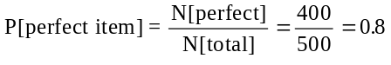 No. of perfect items=0.8x10000 = 8000

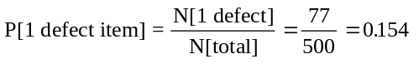 No. 1 defect items=0.154x10000 = 1540

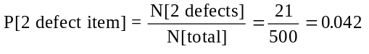 No. 2 defect items=0.042x10000 = 420

To find the costs:
The cost of producing 10,000 items 5x10,000 = £50,000

To find the sales income:
Sale of 8,000 perfect items 9x8,000 = £72,000
Sale of 1540 items with 1 defect 4x1540 = £ 6,160
Sale of 420 items with 2 defects 2x420 = £ 840
Total sales income £79,000

Profit = Income - cost = 79,000 - 50,000 = £29,000 .

If the proportions of defective items in the population as a whole are the same as those found in the batch which was examined then a profit of £29,000 per week may be expected, assuming that production per week is 10,000 items.

4. (i) This is the number of ways of choosing 6 from 49 without repetition when order of choice does not matter, that is, 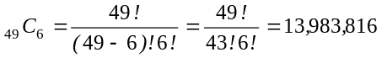
(ii) This is

If a calculator which can calculate combinations is not available the factorials must be written out in the fashion set out above, factors common to both numerator and denominator may be cancelled out to simplify the arithmetic leaving a comparatively simple calculation needed to find the answer.

5. The first step is to define clearly all of the events.
Call the event that an error occurs in the Packing Department A. P[A] = 1 - 0.98 = 0.02
The event that an error in the Packing Department does not occur is then A^{c}. P[A^{c}] = 0.98

Call the event that an error occurs in the Finance Department B. P[B] = 1 - 0.99 = 0.01
The event that an error in the Finance Department does not occur is then B^{c}. P[B^{c}] = 0.99

(i) The probability that the correct goods and bill are despatched id P[A^{c} and B^{c}] = 0.98x0.99 = 0.9702
(ii) The probability that an error occurs somewhere in the process is

(iii) Call the event that an item is not in stock C . Then P[C] = 0 .03 .
The event that the item is in stock is C^{c} and P[C^{c}] = 1 - 0.03 = 0.97
The probability that a customer receives the correct order on time with the correct bill is

to 4 decimal places.

6. There are 5 contaminated and 45 uncontaminated drums. Label the choice of a contaminated drum C and an uncontaminated drum G. The order in which the drums are chosen is not important, simply the number of Cs and Gs in the sample.
Step 1: Define the sample description space. This is a list of the number of ways in which ANY 5 drums can be chosen from the 50 available when order of choice does not matter.
There are N [S] = ₅₀C₅ = 2118760 (from the calculator) ways of doing this.
(i) Step 2: Define the event of interest in relation to the s.d.s. This is the event that zero drums are contaminated, that there are 5 Gs in the sample, call this event A.
N[A] = number of ways to choose 5 from 45 when order doesn't matter.
= ₄₅C₅ = 1221759
P[A] = N[A]/N[S] = 1221759/2118760 = 0.5766 to 4 decimal places.
There is a probability of 0.5766 that the sample will contain only uncontaminated drums.

(ii) Step 3: Define the event of interest in relation to the s.d.s. This is the event that 1 drum is contaminated and 4 are not, that there are 4 Gs and 1 C in the sample, call this event B.
N[B] = (no ways to choose 4 Gs from 45)×(no ways to choose 1 C from 5)
= ₄₅C₄ × ₅C₁
= 148995×5 = 744975
P[B] = N[B]/N[S] = 744975/2118760 = 0.3516 to 4 decimal places.
There is a probability of 0.3516 that the sample will contain exactly 1 drum with contaminated material.

(iii) Step 3: Define the event of interest in relation to the s.d.s. This is the event that two or less drums are contaminated. This means the event that the sample contains exactly 0 or 1 or 2 drums which are contaminated. We have already calculated the probabilities of 0 or 1 contaminated drum in the sample and so need to find the probability of getting exactly 2 Cs in the sample, call this event D.
N[D] = (no ways to choose 3 Gs from 45)×(no. ways to choose 2 Cs from 5)
= ₄₅C₃ × ₅C₂
= 14190×10 = 141900
P[D] = N[D]/N[S] = 141900/2118760 = 0.0670 to 4 decimal places.

P[2 or less Cs] = P[(0 Cs)∪(1 C)∪(2 Cs)] = 0.5766 + 0.3516 + 0.0670 = 0.9952

The probability that the sample of 5 drums contains two or less contaminated drums is 0.9952.

This also defines the probability of there being more than two, which is the same as saying three or more or at least three contaminated drums since this is the complement of two or less.
P[2 or less Cs] + P[more than 2 Cs] = 1
Hence P[at least 3 Cs] = 1 - 0.9952 = 0.0048

7. The only way that the system will fail is if all 3 components fail.
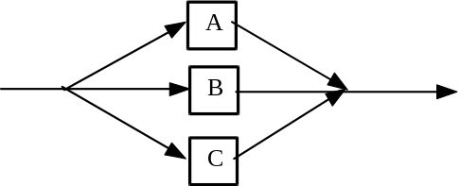
Call the event the event that component A fails A.
Call the event the event that component B fails B.
Call the event the event that component C fails C.

P[A] = P[B] = P[C] = 1 - 0.99 = 0.01
Since the components are independent of one another
P[A∩B∩C] = P[A]×P[B]×P[C] = 0.013 = 0.000001 is the probability that the system does not work after 90 hours.
The probability that the system still works after 90 hours is given as 1 - P[A∩B∩C] = 0.999999 .

8. With a batch of 10,000 items containing 10% defective items the removal of a sample of size n=5 will have negligible effect of the proportion of defectives in the remainder of the batch. Label a defective item D and a good item G. We are told that P[D] = 0.1 and P[G] = 0.9 . Where several items are chosen the order of their selection is the order in which they are written.
a) (i) If there are no defectives in the sample there must be 5 good items. We are looking for
P[G∩G∩G∩G∩G] = P[G]× P[G]× P[G]× P[G]× P[G] = 0.9×0.9×0.9×0.9×0.9 = 0.9⁵
= 0.5905
The probability that the sample contains no defective items is 0.5905.

(ii) There are 5 ways of selecting a sample of size 5 containing exactly 1 defective item. Missing out the AND, ∩, symbol this can be done as DGGGG, GDGGG, GGDGG, GGGDG, GGGGD.

Take the first description:
P[DGGGG] = P[D]×P[G]× P[G]× P[G]× P[G] = 0.1×0.9×0.9×0.9×0.9 = 0.1×0.9⁴ = 0.3281
The probability that a sample of 1 defective item and 4 good items, in that order, is chosen is 0.1×0.9⁴.
The probability that a sample of 1 defective item and 4 good items, in any order, is chosen is
P[DGGGG∪ GDGGG∪ GGDGG∪ GGGDG∪ GGGGD] = PDGGGG]+P[GDGGG]+...+P[GGGGD]
= 5×P[DGGGG] = 5×0.1×0.9⁴ = 0.3281
The probability that the sample contains 1 defective item is 0.3281.

(iii) Call the number of defective items in the sample x, and let P[x=0] = f(0), P[x=1] = f(1), then
P[x ≤ 1] = f(0) + f(1) = 0.5905 + 0.3281 = 0.9186.
The probability that the sample contains 1 or less defective items is 0.9186.
The probability that the sample contains more than 1 defective item, that is, 2 or more defectives is given by
P[x ≥ 2] = 1 - P[x ≤ 1] = 1 - 0.9186 = 0.0814 .
The probability that the sample contains two or more defective items is 0.0814.

b) (i) We wish to find the probability that the batch is accepted at the second sampling stage. This is given by
P[(a second sample is taken)∩(the second sample has zero defectives)].
We know from Part a(ii) above that P[second sample is taken] = 0.3281.
Since the batch size is very large the content of the second sample is not affected by the taking of the first sample.
P[0 defectives in second sample] = P[0 defectives in first sample] = 0.5905.
P[accept after 2 samples] = P[1 defective in 1st sample]×P[0 defectives in second sample]
= 0.3281×0.5905 = 0.1937.
The probability of accepting the batch at the second sample stage is 0.1937.

(ii) The total probability of accepting the batch
P[accept at the first stage] + P[accept at 2nd stage] = 0.5905 + 0.1937 = 0.7842.

(iii) The easiest way to find the probability of rejecting the batch is to find
P[reject the batch] = 1 - P[accept the batch] = 1 - 0.7842 = 0.2158.
Check:
This may be checked since it is the sum of the probabilities of rejecting at stage 1 and stage 2.
We have already calculated the first term as P[x ≥ 2] = 0.0814 .
P[reject at stage 2] = P[x = 1 at stage 1]×P[x ≥ 1 at stage 2]
= 0.3281×(1 - 0.59050 = 0.1344.
Then P[batch is rejected] = P[reject at stage 1] + P[reject at stage 2] = 0.0814 + 0.1344 = 0.2158.
The probability that the batch is rejected is 0.2158.

9.
C₆
C₅
C₄
C₃
C₂
C₁

For the whole system to function the following must occur:
either C₁ AND C₂ AND C₃ all work
or C₁ AND C₄ AND C₅ AND C₆ all work
or (C₁ AND C₂ AND C₃) AND (C₁ AND C₄ AND C₅ AND C₆)
Call the event C₁ AND C₂ AND C₃ all work event A.
Call the event C₁ AND C₄ AND C₅ AND C₆ all work event B.
We want P[A∪B] = P[A] + P[B] - P[A∩B]
Label the event that component i still functions after 100 hours C_{i} .
P[A] = P[C₁∩C₂∩C₃] = P[C₁]×P[C₂]×P[C₃] = 0.97×0.98×0.98 = 0.9316
P[B] = P[C₁∩C₄∩C₅∩C₆] = P[C₁]×P[C₄]×P[C₅]×P[C₆] = 0.97×0.99×0.99×0.99 = 0.9412 .
Using the product of the individual probabilities to find the probability of the intersections is only valid if the individual events involved are independent of one another.
The intersection A∩B = (C₁∩C₂∩C₃)∩( C₁∩C₄∩C₅∩C₆) = C₁∩C₂∩C₃∩C₄∩C₅∩C₆
is the intersection of two events which are not independent of one another since C₁ appears in both events.
P[A∩B] = P[C₁∩C₂∩C₃∩C₄∩C₅∩C₆] = 0.97×0.98×0.98×0.99×0.99×0.99 = 0.9039.
P[A∪B] = P[A] + P[B] - P[A∩B] = 0.9316 + 0.9412 - 0.9039 = 0.9689.
The probability that the system still functions after 100 hours is 0.9689.

Note: There is usually more than one way of solving problems of the kind set out in this exercise. If you have the correct solution by a slightly different method this is perfectly acceptable.

